Lab Report – 1

Experiment 1: Testing Not Gate

Moida Praneeth Jain (2022101093, Group 4, Table 16)

**Objective**

* Understanding the components and usage of the digital test kit.
* Measuring Voltage between VCC and GND pins.
* Verify working of input pins and output LEDs.
* Verify 7404 IC (6 NOT gates).

**Electronic Components Required**

* Power Supply
* Breadboard
* LED
* Resistor
* 7404 IC (Hex Inverter)
* Switch
* Wires

**The Reference Circuit**

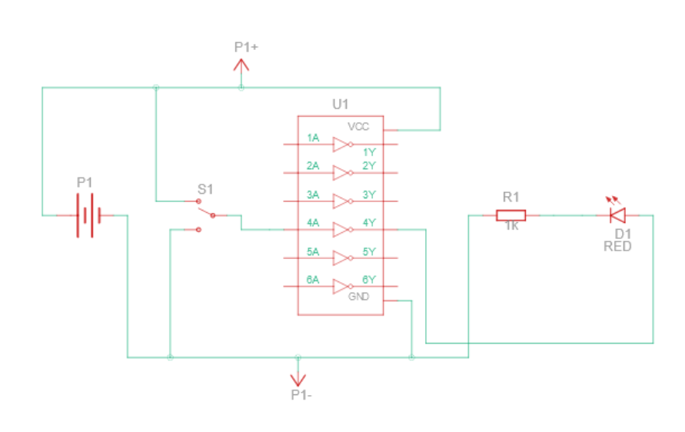

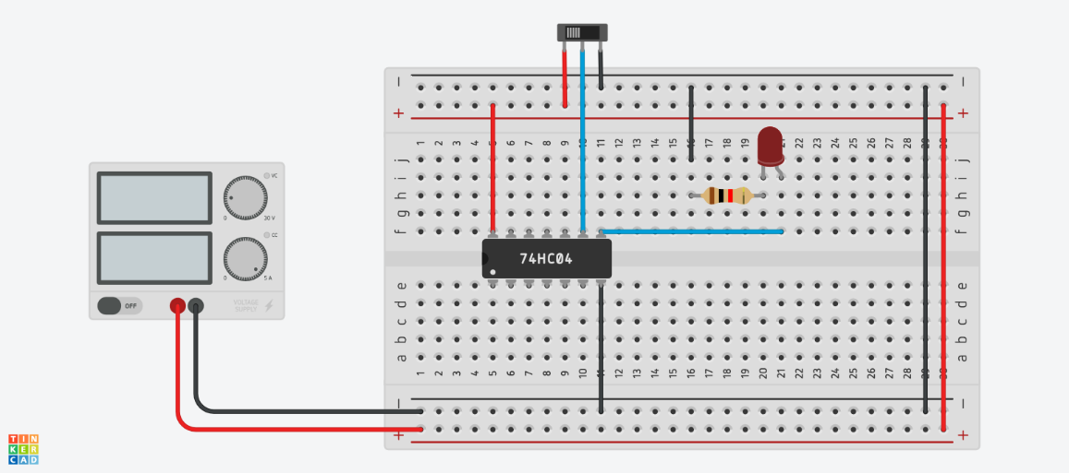

IC:

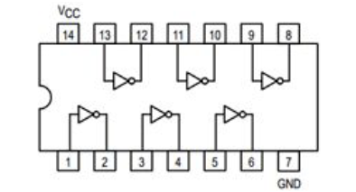

**Procedure**

* Use multimeter to measure voltage between VCC and GND.
* Connect input switches to LED to verify that they are working.
* Connect the IC onto the breadboard.
* Connect VCC to the VCC pin of the IC, and connect GND to the GND pin of the IC (using red and black wires respectively).
* Connect output of any switch to each input switch of the IC, and connect the corresponding output to LED’s anode.
* Connect LED’s cathode to GND through a resistor.
* Turn the power supply on.

**Observation**

* When the input switch is on, the LED is green.
* When the output switch is off, the LED is red.

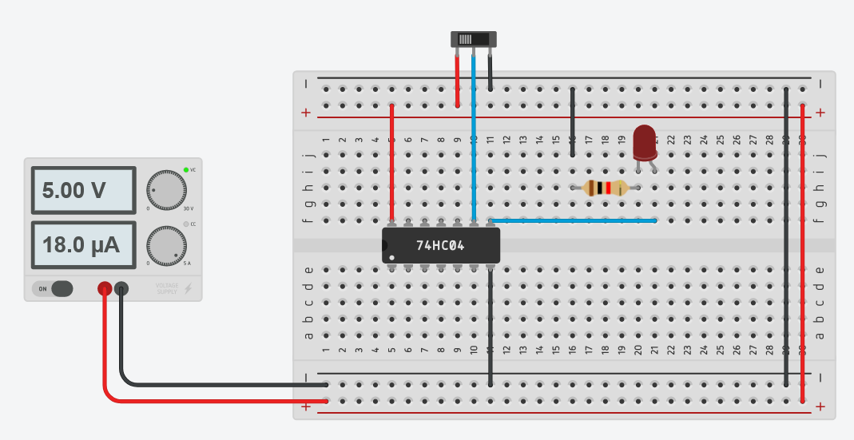

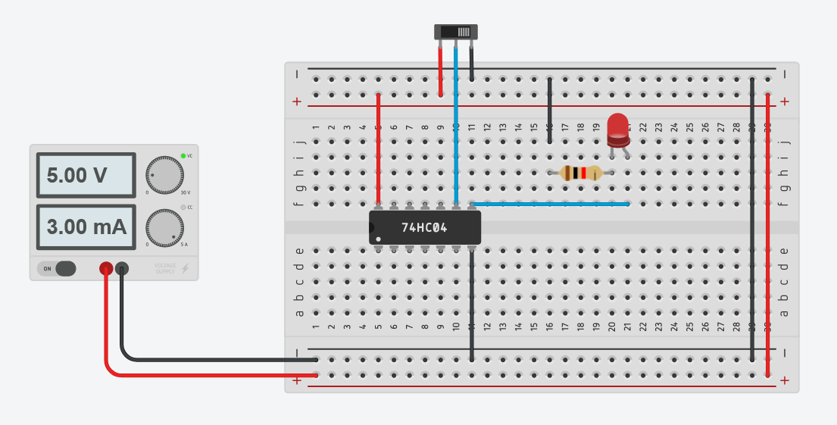

**Conclusion**

The NOT Gates are functioning as expected.

TinkerCAD simulation link:

<https://www.tinkercad.com/things/26rGVuvhCry-experiment-1/editel?sharecode=xx54mB6UG6GT_MbxxYydsvaarcaJMiOoTPbwpHqZvtA>

Experiment 2: Testing Arduino

Moida Praneeth Jain (2022101093, Group 4, Table 16)

**Objective**

* Connect Arduino Uno to breadboard and output “Hello World” in the serial monitor when output of NOT gate is 1 and output nothing when output of NOT gate is 0.

**Electric Components Required**

* Power Supply
* Breadboard
* Arduino Uno
* 7404 IC (Hex Inverter)
* Wires
* Switch

**The Reference Circuit**

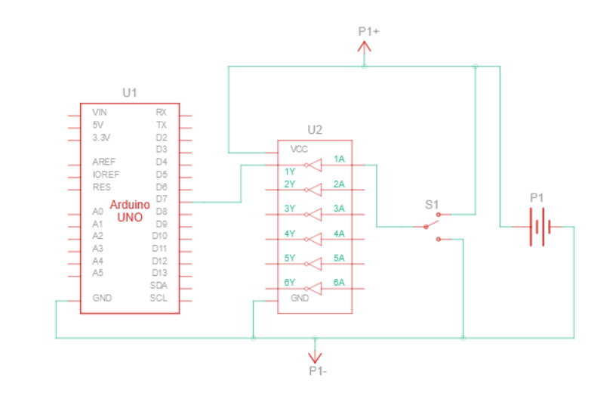

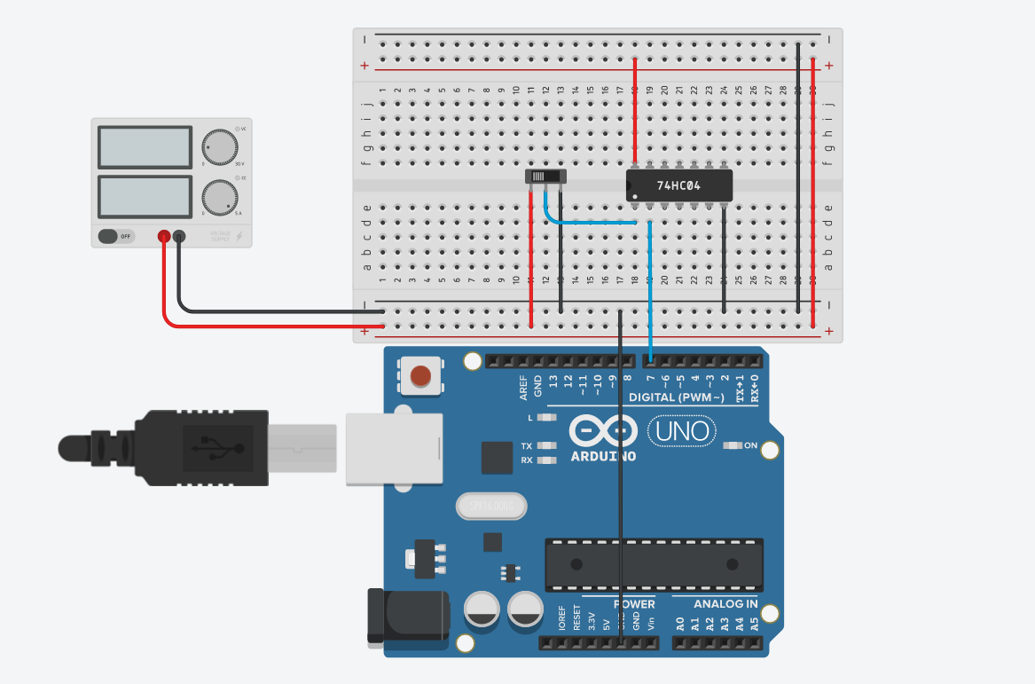

**Code**

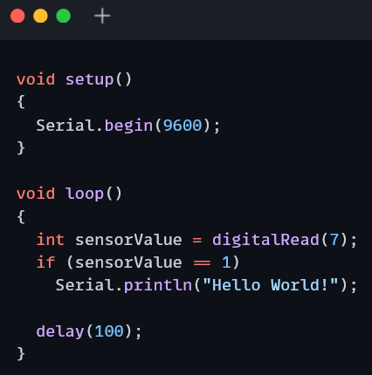

**Procedure**

* Connect the IC onto the breadboard.
* Connect VCC to the VCC pin of the IC and GND to the GND pin of the IC (with red and black wires respectively).
* Connect GND to GND of Arduino.
* Connect output of any switch to any input of the IC, and connect the corresponding output to a digital input pin of the Arduino.
* Connect the Arduino to your PC and load the code using Arduino IDE.
* Turn the power supply on.

**Observation**

* When the switch is off, “Hello World” is printed on the serial monitor. When the switch is on, nothing is printed.

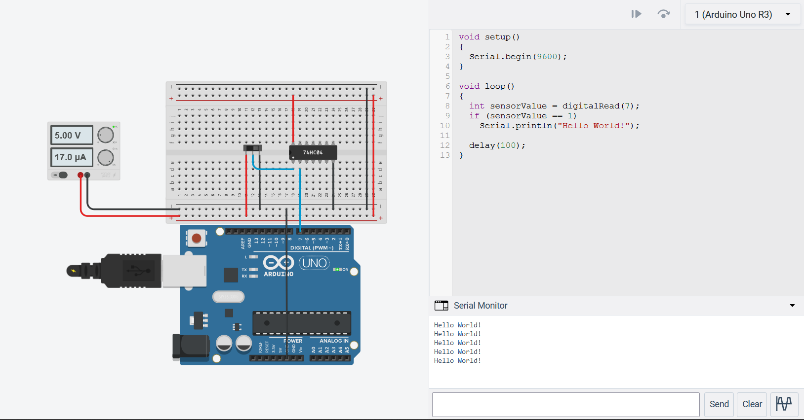

**Conclusion**

The Arduino is working as expected

TinkerCAD simulation link:

<https://www.tinkercad.com/things/kyuP9PE0Kcp-experiment-2/editel?sharecode=KyIsZ7Gj3oFpofBOUQ44KDfoJ7GKuoxLFDxtNS9m6wU>